1. Reversi

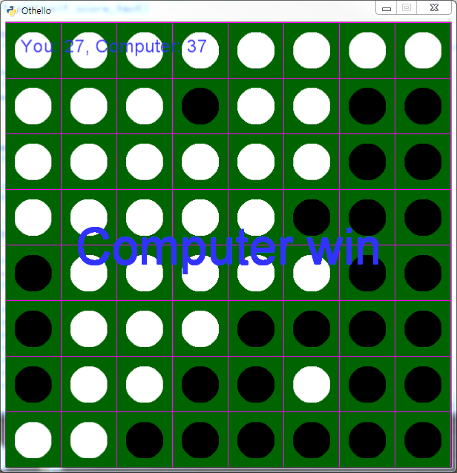

|  |
| --- |
| Description] |
| Code] |
| Game Shot] |